**GAS LEAKAGE MONITORING & ALERTING SYSTEM FOR INDUSTRIES**

USING INTERNET OF THINGS

*A Project report submitted in partial fulfilment of 7th semester in degree of*

BACHELOR OF ENGINEERING

IN

**COMPUTER SCIENCE AND ENGINEERING**

***Submitted by***

Team ID: PNT2022TMID51954

|  |  |
| --- | --- |
| Mothika R | 962319104058 |
| Mani K V | 962319104056 |
| Padmesh G N | 962319104066 |
| Sree Varsha S V | 962319104088 |
|  |  |



**DEPARTMENT OF COMPUTER SCIENCE AND ENGINEERING**

**AMRITA COLLEGE OF ENGINEERING AND TECHNOLOGY**

ANNA UNIVERSITY: CHENNAI 600025

**NOV-2022**

**AMRITA COLLEGE OF ENGINEERING AND TECHNOLOGY**

# (A Constituent College of Anna University, Chennai)



**BONAFIDE CERTIFICATE**

Certified that this project report **“GAS LEAKAGE MONITORING & ALERTING SYSTEM FOR INDUSTRIES”** is the bonafide record work done by **Ms MOTHIKA R**(**962319104058**)**,** **Mr MANI K V (962319104056),** **Mr PADMESH G N(962319104066)** and **Ms SREE VARSHA S V**(**962319104088**) for **IBM-NALAIYATHIRAN** in **VII** semester of **B.E.,** degree course **in Computer Science and Engineering** branch during the academic year of 2022 - 2023.

# Staff-In charge Evaluator

**Mrs.Karpagavalli C V**

# Head of the Department Dr.Sivaraja P M

**ACKNOWLEDGEMENT**

We express our breathless thanks to our **Dr.T.Kannan, M.E., Ph.D.,** the principal, Amrita College of Engineering and Technology, Erachakulam, for giving constant motivation in succeeding in our goal.

We acknowledge our sincere thanks to Head of the Department (i/c) **Dr. P M Siva Raja M.Tech., Ph.D.,** for giving us valuable suggestion and help towards us throughout this Project.

We are highly grateful to thank our Project coordinator **Mrs.Karpagavalli C V**

and our Project Evaluator **Mrs.Jothi Lakshmi S.L** Department of Computer Science and Engineering, Amrita college of Engineering and Technology for the coordinating us throughout this Project.

We are very much indebted to thank all the faculty members of Department of Computer science and Engineering in our Institute, for their excellent moral support and suggestions to complete our Project work successfully.

Finally our acknowledgment does our parents, sisters and friends those who had extended their excellent support and ideas to make our Project a pledge one.

**Mothika R**

**Mani K V**

**Padmesh G N**

**Sree Varsha S V**

# TABLE OF FIGURES

1. INTRODUCTION
   1. Project Overview
   2. Purpose
2. LITERATURE SURVEY
   1. Existing problem and reference
3. IDEATION & PROPOSED SOLUTION
   1. Empathy Map Canvas
   2. Ideation & Brainstorming
   3. Proposed Solution
   4. Problem Solution fit
4. REQUIREMENT ANALYSIS
   1. Functional requirement
   2. Non-Functional requirements
5. PROJECT DESIGN
   1. Data Flow Diagrams
   2. Solution & Technical Architecture
   3. User Stories
6. PROJECT PLANNING & SCHEDULING
   1. Sprint Planning & Estimation
   2. Sprint Delivery Schedule
7. CODING & SOLUTIONING
   1. Feature 1(CODE FOR GAS LEAKAGE MONITORING AND ALERTING SYSTEM BY LINKING TO IBM CLOUD)
   2. Feature 2(OUTPUT)
8. TESTING
   1. Test Cases
   2. User Acceptance Testing
9. RESULTS
   1. Performance Metrics
10. ADVANTAGES & DISADVANTAGES
11. CONCLUSION
12. FUTURE SCOPE
13. APPENDIX

Source Code

GitHub & Project Demo Link

# GAS LEAKAGE MONITORING & ALERTING SYSTEM FOR INDUSTRIES

# 1.INTRODUCTION

# 1.1Project overview

# Internet of Things aim towards making life simpler by automating every small task around us.As much is IoT helping in automating tasks, the benefits of IoT can also be extended for enhancing the existing safety standards. Safety, the elementary concern of any project, has not been left untouched by IoT. Gas Leakages in open or closed areas can prove to be dangerous and lethal. The traditional Gas Leakage Detector Systems though have great precision, fail to acknowledge a few factors in the field of alerting the people about the leakage. Therefore we have used the IoT technology to make a Gas Leakage Detector for society which having Smart Alerting techniques involving sending text message to the concerned authority and an ability performing data analytics on sensor readings. Our main aim is to proposing the gas leakage system for society where each flat have gas leakage detector hardware. This will detect the harmful gases in environment and alerting to the society member through alarm and sending notification

# 1.2 Purpose

Internet of Things aim towards making life simpler by automating every small task around us. As much is IoT helping in automating tasks, the benefits of IoT can also be extended for enhancing the existing safety standards. Safety has always been an important criterion while designing home, buildings, industries as well as cities. The increased concentration of certain gases in the atmosphere can prove to be extremely dangerous. These gases might be flammable at certain temperature and humidity conditions, toxic after exceeding the specified concentrations limits or even a contributing factor in the air pollution of an area leading to problems such as smog and reduced visibility which

can in turn cause severe accidents and also have adverse effect on the health of people.Most of the societies have fire safety mechanism. But it can use after the fire exists. In order to have a control over such conditions we proposed system that uses sensors which is capable detecting the gases such as LPG, CO2, CO and CH4.

This system will not only able to detect the leakage of gas but also alerting through audible alarms.Presence of excess amounts of harmful gases in environment then this system can notify the user. System can notify to society admin about the condition before mishap takes place through a message..

System consists of gas detector sensors, Arduino board, ESP8266 and Cloud server. One Societyauthority person can register the all flat member user to our system. Society admin can add the details of per flat user such as user name, mobile number, per user flat sensor details information. Society admin can configure the threshold value of each sensor. System hardware can be deployed on each flat. Sensors can sense the value per time. System can send the values to cloud server. Server can Check that the sensor values was existed the threshold value. If sensor value can cross the limit the server can send the command to hardware for buzzing the alarm. Server also sends the notification message to user

# LITERATURE SURVEY

## . 1. TITLE:[Hazardous Gas Detection and Notification System](https://ieeexplore.ieee.org/document/8666358/)

# AUTHOR: [Maribelle JUALAYBA](https://ieeexplore.ieee.org/author/37086800314);[Kristian REGIO](https://ieeexplore.ieee.org/author/37086800345);[Harold QUIOZON](https://ieeexplore.ieee.org/author/37086800315);[Adrian DESTREZA](https://ieeexplore.ieee.org/author/37086799644)

# YEAR OF PUBLICATION: 2018

# PUBLISHED IN: [2018 IEEE 10th International Conference on Humanoid, Nanotechnology, Information Technology,Communication and Control, Environment and Management (HNICEM)](https://ieeexplore.ieee.org/xpl/conhome/8662828/proceeding)

# ABSTRACT: Hazardous gases like propane and methane are combustible and could cause explosion if confined in a close room. The study described in this paper comprises a system that involves detection and notification of hazardous gases present in an area. The system has three sensors; hydrogen sensor, Liquefied Petroleum Gas (LPG) sensor, and methane sensor that serve as switches with different set-points. Every level of gas detected is send to the Arduino that serves as the controller which analyze the level of gas present. The controller is also in charge for triggering the lamp, exhaust fan, buzzer, Liquid Crystal Display (LCD) monitor and Global System Mobile (GSM) module. The system has three lamps that indicate the level of gas being detected. Green light means “safe level”, yellow means “medium level”, and red for “danger level”. The exhaust fan is activated as the controller detects medium level, which is simultaneous with the lighting of the yellow light and will only be deactivated when the system detects again safe level. The buzzer is activated as the controller detects danger level which is synchronized with the lighting of the red light. The LCD monitor displays the level of gas being detected and the GSM module sends Short Message Service (SMS) as notification to concern people.

## 2. TITLE: [Smart Gas Leakage Detection with Monitoring and Automatic Safety System](https://ieeexplore.ieee.org/document/9032872/)

# AUTHOR: [S.M. Zinnuraain](https://ieeexplore.ieee.org/author/37088335783);[Mahmudul Hasan](https://ieeexplore.ieee.org/author/37085340607);[Md. Akramul Hakque](https://ieeexplore.ieee.org/author/37088334928);[Mir Mohammad Nazmul Arefin](https://ieeexplore.ieee.org/author/37088334752)

# YEAR OF PUBLICATION: 2019

# PUBLISHED IN: [2019 International Conference on Wireless Communications Signal Processing and Networking (WiSPNET)](https://ieeexplore.ieee.org/xpl/conhome/9027608/proceeding)

# ABSTRACT: In this paper, we have proposed a LPG (Liquified Petroleum Gas) leakage detection with monitoring and automatic safety system. With the drastically increased demand and use of LPG, this system would be helpful to monitor the usage of LPG on a regular basis and to take safety about any hazards that may occur due to LPG leakage. We have designed a system that notify the user using IOT (Internet of Things) through mobile app about the amount of LPG so that appropriate measures can be taken. Since LPG is a highly hazardous and inflammable gas, we have also designed a safety system to with the help of IOT (Internet of Things) through mobile app, when any leakage occurs in LPG so that necessary safety can be taken to avoid an explosion.

## 3. TITLE: [Methane Leakage Monitoring Technology for Natural Gas Stations and Its Application](https://ieeexplore.ieee.org/document/9064041/)

# AUTHOR: [Bing Han](https://ieeexplore.ieee.org/author/37086264573);[Qiang Fu](https://ieeexplore.ieee.org/author/37086264135);[Yi Huang](https://ieeexplore.ieee.org/author/37088367022);[Hanfang Hou](https://ieeexplore.ieee.org/author/37086380190)

# YEAR OF PUBLICATION: 2019

# PUBLISHED IN: [2019 IEEE 5th International Conference on Computer and Communications (ICCC)](https://ieeexplore.ieee.org/xpl/conhome/9048180/proceeding)

# ABSTRACT: In natural gas stations, leakage monitoring technologies are of great significance for immediately identifying gas leakage and minimizing various losses caused therefrom. The Fiber Bragg Grating (FBG) sensing technology is applied to monitor key areas and equipment in natural gas stations that may suffer methane leakage, considering the shortcomings of existing leakage monitoring technologies applied for the natural gas stations, i.e. high false alarm rate, poor stability, easy to be interfered by background gas, etc. The false alarm rate can be effectively reduced by simultaneously monitoring the leakage vibration and methane concentration. Results of laboratory tests indicate that the monitoring technology proposed in this paper enjoys such advantages as low cost, easy-to-install and high reliability, and can be extensively applied for monitoring the methane leakage in natural gas stations and valve chambers of long-distance and gathering pipelines.

## 4. TITLE: [Pipeline Gas Leakage Detection And Location Identification System](https://ieeexplore.ieee.org/document/8878721/)

# AUTHOR: [M. Pajany](https://ieeexplore.ieee.org/author/37087057182);[A. Hemalatha](https://ieeexplore.ieee.org/author/37085361862)

# YEAR OF PUBLICATION: 2019

# PUBLISHED IN: [2019 IEEE International Conference on System, Computation, Automation and Networking (ICSCAN)](https://ieeexplore.ieee.org/xpl/conhome/8870340/proceeding)

# ABSTRACT: Every diminutive task in this planetary is machine-controlled by cyberspace of belongings which makes our life easier. Now internet of things is used for safety purpose also. Nowadays outflow of gas in pipeline is the major difficulty. The chief mental object of this project is to detect the leakage of gases in the pipeline. Pipeline will be monitored with in an regular intervals using gas detection sensors. If there is any leakage in the pipeline then it will be detected and information such as name of the gas, pressure rate of the gas and its location where there is leakage of gases will be passed to the mobile phone, laptops, etc using IOT. The accurate location for the gas leakage will be detected using the GPS. Advantages of this employment is,used to prevent failure of lives due to blow up, fire, etc.

## 5. TITLE: [IoT and ML based Smart System for Efficient Garbage Monitoring: Real Time AQI monitoring and Fire Detection for dump yards and Garbage Management System](https://ieeexplore.ieee.org/document/9214202/)

# AUTHOR: [Dev V. Savla](https://ieeexplore.ieee.org/author/37088524978);[Amogh N. Parab](https://ieeexplore.ieee.org/author/37088523091);[Kaustubh Y. Kekre](https://ieeexplore.ieee.org/author/37088521361);[Jay P. Gala](https://ieeexplore.ieee.org/author/37088524229);[Meera Narvekar](https://ieeexplore.ieee.org/author/37085471722)

# YEAR OF PUBLICATION: 2020

# PUBLISHED IN: [2020 Third International Conference on Smart Systems and Inventive Technology (ICSSIT)](https://ieeexplore.ieee.org/xpl/conhome/9203793/proceeding)

# 

# ABSTRACT: There is always a significant amount of challenges associated with waste and its disposal, which can be essentially mitigated by the use of technology. As the urban population increases, the amount of waste disposal is also increasing at an unprecedented rate. The inappropriate disposal of this waste will lead to many hazards including the risk of fires in the dump yards that leverages poisonous smoke in the atmosphere by adversely affecting the safety of nearby residential areas. Monitoring the occurrence of fire in huge dumping grounds manually is a tough task and thus developing an automatic fire extinguishing system is highly required. The advanced technologies can be leveraged to ensure the protection and safety of people by eliminating such hazardous risks. The air quality index (AQI) is an indicator of daily air quality report that shows how air quality affects a person's life in a very short time. AQI plays a key role in ensuring the safety of residential areas. The proposed system aims to aid the possible hazardous risks associated with the dump yard and waste management.

## 6. TITLE: [Sulfur Hexafluoride Gas Leakage Monitoring and Early-Warning Method for Electrical Power Facilities](https://ieeexplore.ieee.org/document/9139917/)

# AUTHOR: [Chunrui Liu](https://ieeexplore.ieee.org/author/37088340884);[Fujie Deng](https://ieeexplore.ieee.org/author/37088447266);[Lei Shi](https://ieeexplore.ieee.org/author/37088146901);[Feng Wang](https://ieeexplore.ieee.org/author/37086956010)

# YEAR OF PUBLICATION: 2020

# PUBLISHED IN:  IEEE

# 

# ABSTRACT: Most transformer substations in power supply facilities rely on sulfur hexafluoride electrical equipment. A sulfur hexafluoride gas leak can cause serious health concerns if effective measures are not adopted in time. Therefore, in this study, a sulfur hexafluoride gas leakage monitoring, early-warning, and emergency disposal model was established. First, taking the main transformer chamber of an underground transformer substation as the research object, a 3D-model was built, and a numerical simulation was performed. Second, the simulation results were utilized to determine the dispersion and concentration distribution of the sulfur hexafluoride gas, identify concentration-sensitive areas, and arrange sensors based on the simulation results, to ensure early-warning in case of leaks. Then, a sulfur hexafluoride gas leakage monitoring and early-warning model was built based on the data collected using sensors at the monitoring points; thereafter, a construction method was developed for a sulfur hexafluoride gas leakage emergency disposal model, which can be referenced to establish a leakage gas recycling system. This paper also provides some recommendations regarding the determination of the optimal conditions for this emergency recycling device, which can be utilized to maintain the concentration of sulfur hexafluoride gas below a specified value and to construct a recycling time prediction model. The results of the study can provide a theoretical basis for sulfur hexafluoride gas leakage early-warning and emergency disposal, which will contribute to the prevention of suffocation-related accidents.

## 7. TITLE: [A Smart Natural Gas Leakage Detection and Control System for Gas Distribution Companies of Bangladesh using IoT](https://ieeexplore.ieee.org/document/9331226/)

# AUTHOR: [Hilton Paul](https://ieeexplore.ieee.org/author/37088661220);[Mohammad Khalid Saifullah](https://ieeexplore.ieee.org/author/37088662358);[Md. Monirul Kabir](https://ieeexplore.ieee.org/author/37089403803)

# YEAR OF PUBLICATION: 2021

# PUBLISHED IN: [2021 2nd International Conference on Robotics, Electrical and Signal Processing Techniques (ICREST)](https://ieeexplore.ieee.org/xpl/conhome/9330807/proceeding)

# ABSTRACT: This paper proposes a smart mobile based model of gas leakage detection and control for gas distribution system of Bangladesh using IoT, called as smart natural gas leakage detection and control system (SNLDCS). The proposed SNLDCS has been implemented in both software and hardware modules. The existing researches are about Liquefied Petroleum Gas (LPG) leakage detection that are used for cylinder gas. Therefore, these models are not suitable for gas distributions companies of Bangladesh where natural gas leakage is being controlled from remote placesThe experimental results confirm that, implementation of SNLDCS model in gas distribution system in Bangladesh can provide the quickest detection and rapid resolve of gas leakage. As a result, it will increase safety, decreases system loss and reduces Greenhouse Gas (GHG) emission in the air.

.

# IDEATION & PROPOSED SOLUTION

* 1. **Empathy Map Canvas**

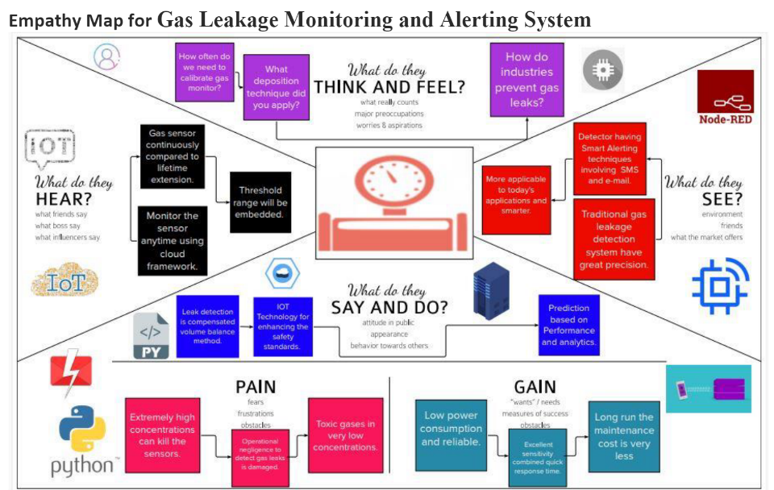

# Ideation & Brainstorming

**Project title:**

**GAS LEAKAGE MONITORING AND ALERTING SYSTEM FOR INDUSTRIES**

**10 minutes to prepare**

**1 hour to collaborate**

**2-8 people recommended**

GROUP IDEAS AND PRIORITIZE

Take turns sharing the ideas while clustering similar or related notes.

TEAM LEADER: MOTHIKA.R

PROBLEM STATEMENT:

Gas leakage is an important aspect to be noted as it can major damage when ignored. It is important to raise an intimation when the gas leakage surpasses certain threshold values. Surveys state that in the oil and gas industry, gas leakage problems occur frequently and lack of proper intimation at those situations leads to hazard. IoT can be utilized for efficient and easy monitoring of gas leakages on a continuous basis and from any distance.

TEAM MEMBER:MANI.K.V

Using Database for input and output

TEAM MEMBER:PADMESH.G.N

**When leakage is sensed, an alert is given through LCD**

TEAM MEMBER:MANI.K.V

**Data collected from the database and sent to concerned device is monitored in the backend server**

**TEAM MEMBER: SREE VARSHA S V**

**Importance**

**If each of these tasks could get done without any difficulty or cost, which would have the most positive impact?**

**appropriate sensors.**

* 1. **Proposed Solution**

|  |  |  |
| --- | --- | --- |
| **S.No.** | **Parameter** | **Description** |
|  | Problem Statement (Problem to be solved) | The problem to be solved is that when there is leakage of gas , there should be some alerting system to indicate and to rectify it immediately. |
|  | Idea / Solution description | Here we come with the idea of building a kit using some of sensors that will be used to sense the leakage of gas level . |
|  | Novelty / Uniqueness | The uniqueness of the system is that when certain level of gas indication is reached and starts leaking the sensor detects and the response is indicated using a led lights , buzzers and a digital monitor. |
|  | Social Impact / Customer Satisfaction | This creates an immediate action when the buzzer sounds and the led is turned to red. Thereby the problem is immediately intimated to the employees and high risk can be avoided. |
|  | Business Model (Revenue Model) | The cost of production is less as for as the system is concerned. |
|  | Scalability of the Solution | The life span of the system is good but the sensor should be appropriate and properly maintained for continuous progress. If the area to be covered is more then many number of such systems can be implemented to avoid risks. |

# Problem Solution fit

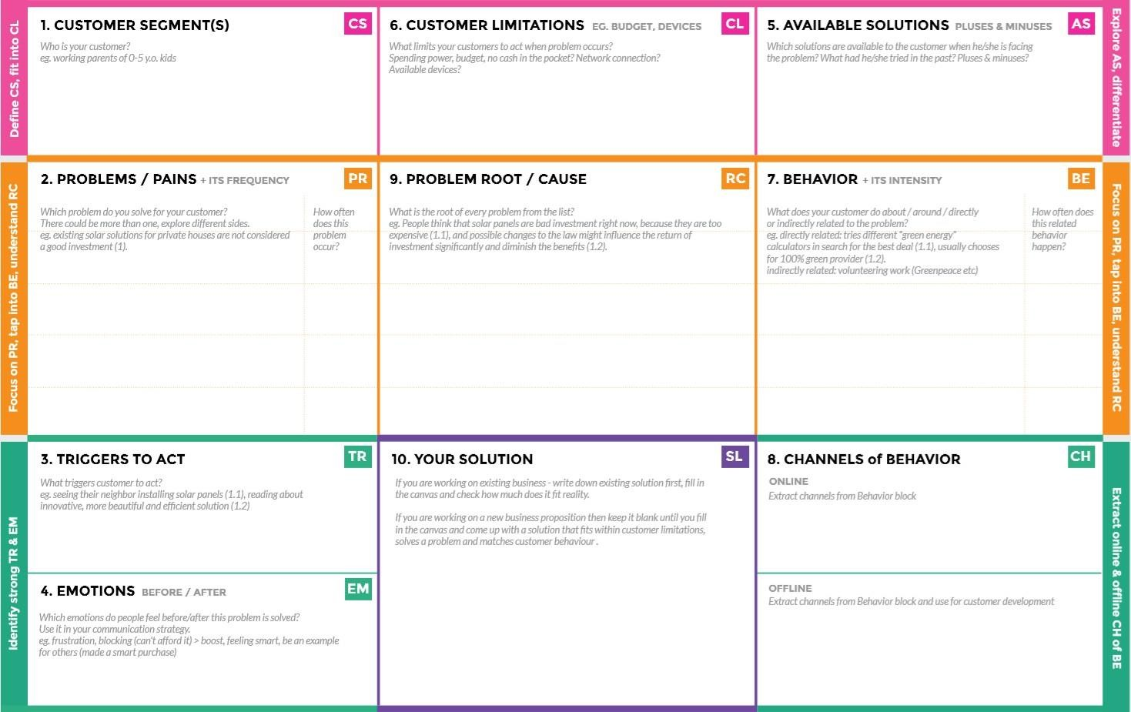

* Using manpower as the source of monitoring the leakage causes high hazards.
* If the gas leaked is heavily toxic, there is a chance of causing hereditary health issues too.

The monitoring and controlling of the leakage could be done by the manpower. Even though man power could reduce electricity cost and monitor properly, it may cause high risk for their life. There is also a cause of some errors due to manpower.

High budget in installing other products make them to move far from modern technologies.

**Before:** The heavy losses due to the leakages made them feel of guilt due to reduced reputation of their products.

**After:** Increased the level of confidence and feel secured

Through newspaper advertisements.

Promoting through social media. With the help of social media entrepreneurs/influencer.

Develop an efficient system & an application that can monitor and alert the workers.

The heavy damages or higher health issues due to the toxic gases urges them to find out a solution as soon as they could possible.

When the workers failed to monitor properly, the gas can cause high risk to their health or the properties of the industry.

* Suffering from many losses due to gas leakage.
* Having no proper system for controlling or monitoring the leakage.
* Facing heavy budget problems in buying and installing a system for monitoring and controlling.

The industrialists who use gases for their manufacturing.

1. **REQUIREMENT ANALYSIS**

# Functional requirement

Following are the functional requirements of the proposed solution.

|  |  |  |
| --- | --- | --- |
| **FR No.** | **Functional Requirement (Epic)** | **Sub Requirement (Story / Sub-Task)** |
| FR-1 | User Registration | Registration through Form Registration through Gmail |
| FR-2 | User Confirmation | Confirmation via Email  Confirmation via OTP |
| FR-3 | Data fetch | The details of the gas leaked will be transferred to IOT system |
| FR-4 | Transferring to user | IOT, WIFI Module |
| FR-5 | Receiving in the end user | Gas level details will be displayed through LCD, an alarm will be beeps and the same data will be sent to user mobile via mail |
|  |  |  |

# Non-functional Requirements:

Following are the non-functional requirements of the proposed solution.

|  |  |  |
| --- | --- | --- |
| **FR No.** | **Non-Functional Requirement** | **Description** |
| NFR-1 | **Usability** | Set of techniques for design and development are implemented. |
| NFR-2 | **Security** | Strategical improvement of the process ensures less risks. |
| NFR-3 | **Reliability** | Accuracy and consistency check is properly maintained. |
| NFR-4 | **Performance** | Achieves the goal and contributes to the existing problem in the industry. |
| NFR-5 | **Availability** | Information about the availability of resources are identified. |
| NFR-6 | **Scalability** | Probability of performance is high. |

# PROJECT DESIGN

* 1. **Data Flow Diagrams**

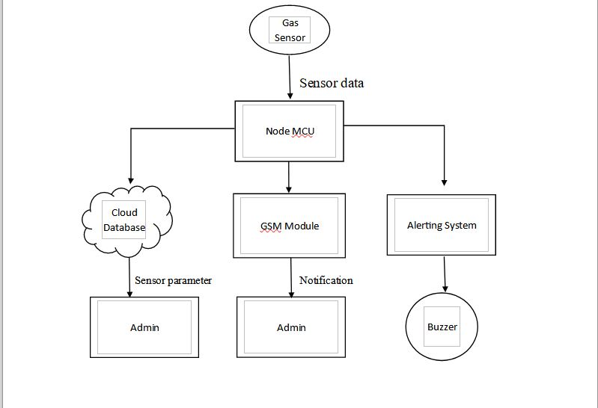

# 

# Solution & Technical Architecture

Technical Architecture:

The Deliverable shall include the architectural diagram as below and the information as per the table1 & table 2

Guidelines:

1. Include all the processes (As an application logic / Technology Block)
2. Provide infrastructural demarcation (Local / Cloud)
3. Indicate external interfaces (third party API’s etc.)
4. Indicate Data Storage components / services
5. Indicate interface to machine learning models (if applicable)

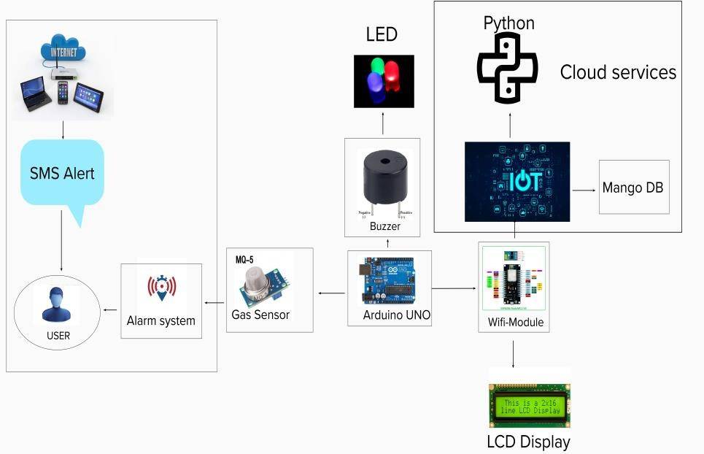

SOLUTION ARCHITECTURE:

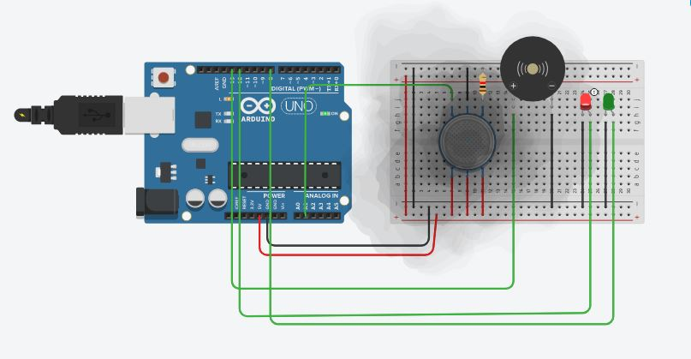

* 1. **User Stories**

|  |  |  |  |  |  |  |
| --- | --- | --- | --- | --- | --- | --- |
| **User Type** | **Functional**  **Requirement (Epic)** | **User Story Number** | **User Story / Task** | **Acceptance criteria** | **Priority** | **Release** |
| Customer (application) | Registration | USN-1 | As a user, I can register for the application by entering my email, password, and confirming my password. | I can access my account / dashboard | High | Sprint-1 |
|  |  | USN-2 | As a user, I will receive confirmation email once I have registered for the application | I can receive confirmation email & click confirm | High | Sprint-1 |
|  |  | USN-3 | As a user, I can register for the application through email | I can register & access the dashboard with mail Login | Low | Sprint-2 |
|  |  | USN-4 | As a user, I can register for the application through Gmail |  | Medium | Sprint-1 |
|  | Login | USN-5 | As a user, I can log into the application by entering email & password |  | High | Sprint-1 |
|  | Dashboard | USN-6 | As a user, I can log in with my credentials to see my dashboard | I will be able to see my dashboard and the application | High | Sprint-2 |
| Customer (Web user) | Dashboard | USN-6 | As a web user, I will go to the application’s URL and login by entering my credentials | I will be able to login and view my dashboard | Medium | Sprint-2 |
| Customer Care Executive | Helping the customers | USN-7 | As a customer care person, I will respond to the customer’s queries | I will be able to see the customer’s difficulties, queries and feedback | High | Sprint- 3 |
| Administrator | Working with data | USN-8 | As an administrator, I can login to the application’s server | I will be able to view the applications data server | High | Sprint-3 |
|  | Asking and responding | USN-9 | As an administrator, I can ask and respond to the customer’s questions | I will be able to answer all the customers | Medium | Sprint-4 |
|  | Maintaining the database | USN-10 | As an administrator, I will be able to view the database | I will be able to view, modify and maintain the application’ s database | High | Sprint-4 |
|  | Managing the overall process | USN-11 | As an administrator, I can control the overall process | I can control and maintain the overall application’ s process | High | Sprint-4 |

# PROJECT PLANNING & SCHEDULING

**6.1 SPRINT PLANNING AND ESTIMATION**

|  |  |  |  |  |  |  |
| --- | --- | --- | --- | --- | --- | --- |
| **Sprint** | **Functional Requirement (Epic)** | **User Story Number** | **User Story / Task** | **Story Points** | **Priority** | **Team Members** |
| Sprint-1 | Registration | USN-1  USN-2 | As a user, I can register for the application by entering my email, password, and confirming my password. | 2 | High | 4 |
| Sprint-1 |  | USN-4 | As a user, I will receive confirmation email once I have registered for the application | 1 | High | 3 |
| Sprint-1 | Login | USN-5 | As a user, I can register for the application through email | 2 | Low | 2 |
| Sprint-2 |  | USN-3 | As a user, I can register for the application through Gmail | 2 | Medium | 3 |
| Sprint-2 | Dashboard | USN-6 | As a user, I can log into the application by entering email & password  As a user, I can log in with my credentials to see my dashboard | 1 | High | 4 |
| Sprint-3 | Customer Care Executive | USN-7 | As a customer care person, I will respond to the customer’s queries | 1 | High | 4 |
| Sprint-3 | Working with data | USN-8 | As an administrator, I can login to the application’s server | 2 | Medium | 3 |
| Sprint-4 | Managing the overall process | USN-9  USN-10  USN-11 | As an administrator, I can ask and respond to the customer’s questions  As an administrator, I will be able to view the database  As an administrator, I can control the overall process | 2 | High | 4 |

Use the below template to create product backlog and sprint schedule

**6.2 SPRINT DELIVERY SCHEDULE**

|  |  |  |  |  |  |  |
| --- | --- | --- | --- | --- | --- | --- |
| **Sprint** | **Total Story Points** | **Duration** | **Sprint Start Date** | **Sprint End Date (Planned)** | **Story Points**  **Completed (as on Planned End Date)** | **Sprint Release Date (Actual)** |
| Sprint-1 | 20 | 6 Days | 24 Oct 2022 | 29 Oct 2022 | 20 | 29 Oct 2022 |
| Sprint-2 | 20 | 6 Days | 31 Oct 2022 | 05 Nov 2022 | 15 | 05 Nov 2022 |
| Sprint-3 | 20 | 6 Days | 07 Nov 2022 | 12 Nov 2022 | 18 | 12 Nov 2022 |
| Sprint-4 | 20 | 6 Days | 14 Nov 2022 | 19 Nov 2022 | 20 | 18 Nov 2022 |

# CODING & SOLUTIONING

7.1 **CODE FOR GAS LEAKAGE MONITORING AND ALERTING SYSTEM BY LINKING TO IBM CLOUD**

#include <WiFi.h>//library for wifi

#include <PubSubClient.h>//library for MQtt

#include "DHT.h"// Library for dht11

#define DHTPIN 15 // what pin we're connected to

#define DHTTYPE DHT22 // define type of sensor DHT 11

#define LED 2

DHT dht (DHTPIN, DHTTYPE);// creating the instance by passing pin and typr of dht connected

void callback(char* subscribetopic, byte* payload, unsigned int payloadLength);

//-------credentials of IBM Accounts------

#define ORG "rwazv5"//IBM ORGANITION ID

#define DEVICE_TYPE "abcd"//Device type mentioned in ibm watson IOT Platform

#define DEVICE_ID "12345"//Device ID mentioned in ibm watson IOT Platform

#define TOKEN "12345678" //Token

String data3;

float h, t;

//-------- Customise the above values --------

char server[] = ORG ".messaging.internetofthings.ibmcloud.com";// Server Name

char publishTopic[] = "iot-2/evt/Data/fmt/json";// topic name and type of event perform and format in which data to be send

char subscribetopic[] = "iot-2/cmd/command/fmt/String";// cmd REPRESENT command type AND COMMAND IS TEST OF FORMAT STRING

char authMethod[] = "use-token-auth";// authentication method

char token[] = TOKEN;

char clientId[] = "d:" ORG ":" DEVICE_TYPE ":" DEVICE_ID;//client id

//-----------------------------------------

WiFiClient wifiClient; // creating the instance for wificlient

PubSubClient client(server, 1883, callback ,wifiClient); //calling the predefined client id by passing parameter like server id,portand wificredential

void setup()// configureing the ESP32

{

Serial.begin(115200);

dht.begin();

pinMode(LED,OUTPUT);

delay(10);

Serial.println();

wificonnect();

mqttconnect();

}

void loop()// Recursive Function

{

h = dht.readHumidity();

t = dht.readTemperature();

Serial.print("temp:");

Serial.println(t);

Serial.print("Humid:");

Serial.println(h);

PublishData(t, h);

delay(1000);

if (!client.loop()) {

mqttconnect();

}

}

/.....................................retrieving to Cloud.............................../

void PublishData(float temp, float humid) {

mqttconnect();//function call for connecting to ibm

/*

creating the String in in form JSon to update the data to ibm cloud

*/

String payload = "{\"temp\":";

payload += temp;

payload += "," "\"Humid\":";

payload += humid;

payload += "}";

Serial.print("Sending payload: ");

Serial.println(payload);

if (client.publish(publishTopic, (char*) payload.c_str())) {

Serial.println("Publish ok");// if it sucessfully upload data on the cloud then it will print publish ok in Serial monitor or else it will print publish failed

} else {

Serial.println("Publish failed");

}

}

void mqttconnect() {

if (!client.connected()) {

Serial.print("Reconnecting client to ");

Serial.println(server);

while (!!!client.connect(clientId, authMethod, token)) {

Serial.print(".");

delay(500);

}

initManagedDevice();

Serial.println();

}

}

void wificonnect() //function defination for wificonnect

{

Serial.println();

Serial.print("Connecting to ");

WiFi.begin("Wokwi-GUEST", "", 6);//passing the wifi credentials to establish the connection

while (WiFi.status() != WL_CONNECTED) {

delay(500);

Serial.print(".");

}

Serial.println("");

Serial.println("WiFi connected");

Serial.println("IP address: ");

Serial.println(WiFi.localIP());

}

void initManagedDevice() {

if (client.subscribe(subscribetopic)) {

Serial.println((subscribetopic));

Serial.println("subscribe to cmd OK");

} else {

Serial.println("subscribe to cmd FAILED");

}

}

void callback(char* subscribetopic, byte* payload, unsigned int payloadLength)

{

Serial.print("callback invoked for topic: ");

Serial.println(subscribetopic);

for (int i = 0; i < payloadLength; i++) {

//Serial.print((char)payload[i]);

data3 += (char)payload[i];

}

Serial.println("data: "+ data3);

if(data3=="lighton")

{

Serial.println(data3);

digitalWrite(LED,HIGH);

}

else

{

Serial.println(data3);

digitalWrite(LED,LOW);

}

data3="";

}

**i) Tinkercad circuit view**

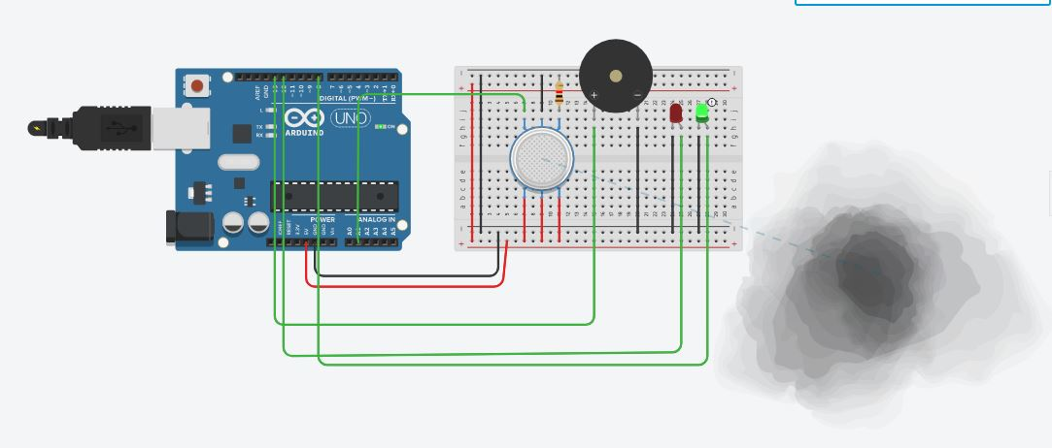



**ii) Schematic View**

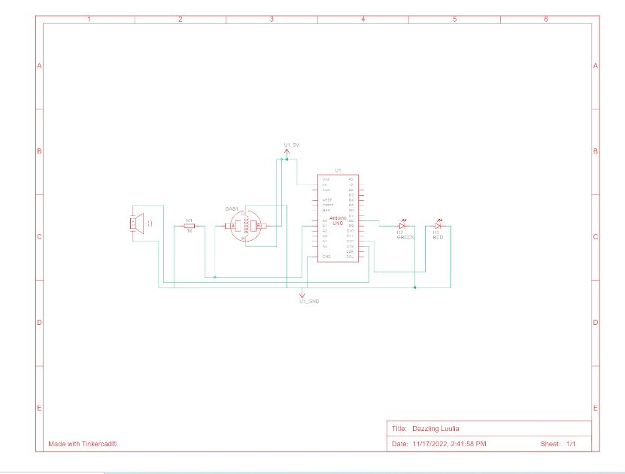

**iii) Wokwi simulation view**

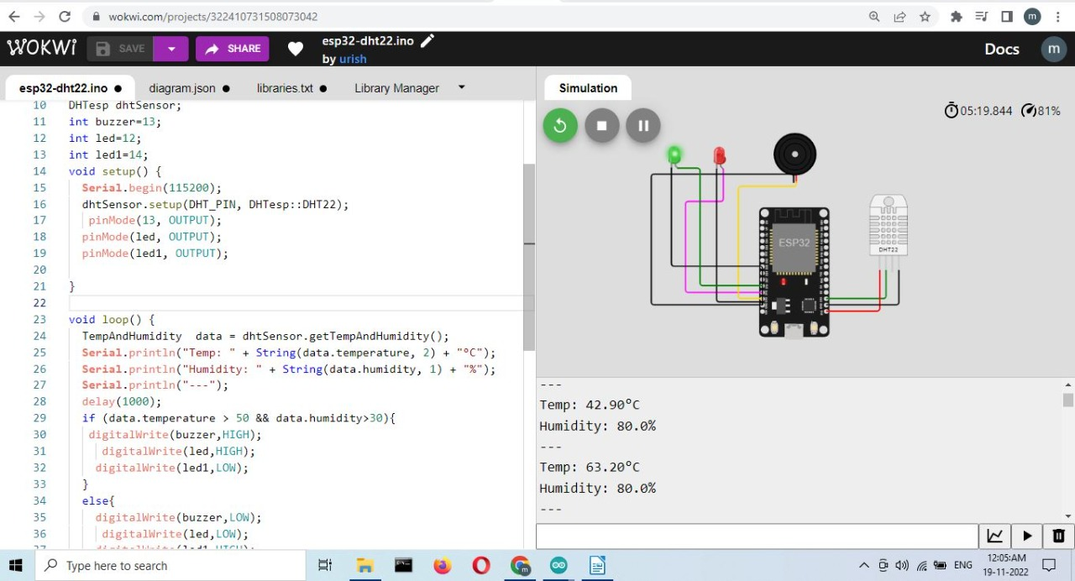

**iv) IBM Device Setup**

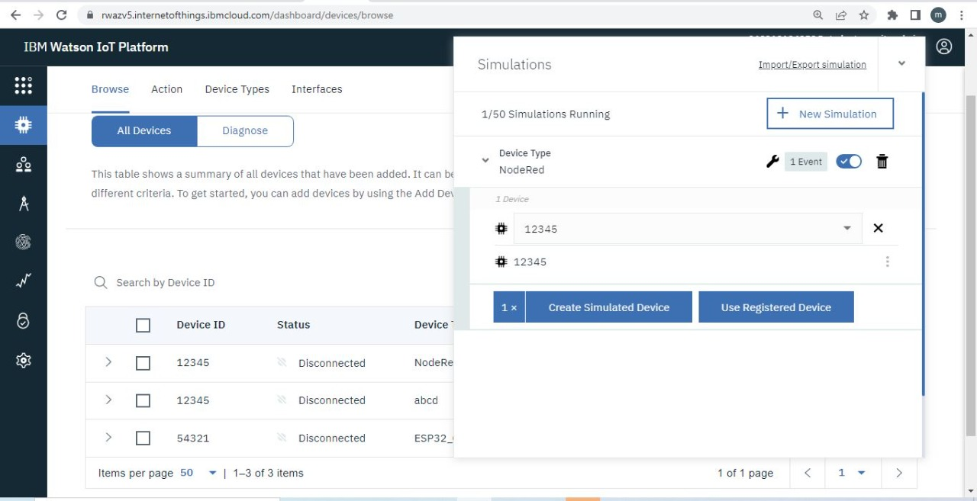

**v) Node Flow Connection using Node-Red**

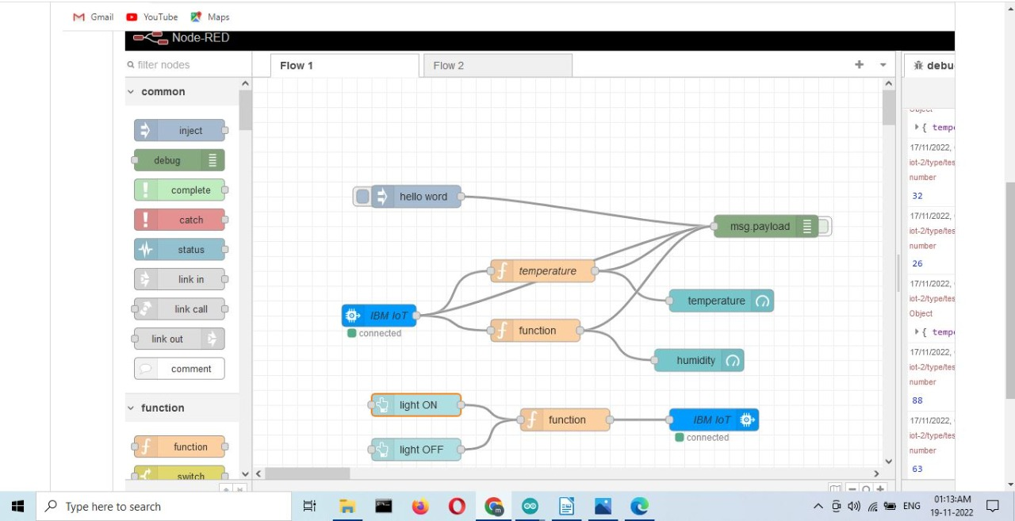

**vi) Web UI using Node-Red**

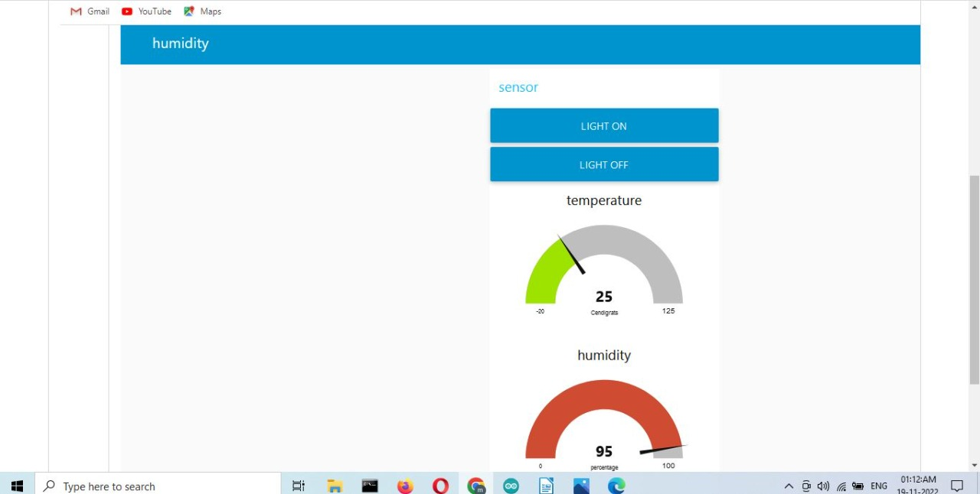

# TESTING

* 1. **Test Cases**

# Test Case Analysis

This report shows the number of test cases that have passed, failed, and untested

|  |  |  |  |  |
| --- | --- | --- | --- | --- |
| **Section** | **Total Cases** | **Not Tested** | **Fail** | **Pass** |
| Print Engine | 7 | 0 | 0 | 7 |
| Client Application | 51 | 0 | 0 | 51 |
| Security | 2 | 0 | 0 | 2 |
| Outsource Shipping | 3 | 0 | 0 | 3 |
| Exception Reporting | 9 | 0 | 0 | 9 |
| Final Report Output | 4 | 0 | 0 | 4 |
| Version Control | 2 | 0 | 0 | 2 |

**8.2 USER ACCEPTANCE TESTING**

# Defect Analysis

This report shows the number of resolved or closed bugs at each severity level, and how they were resolved

|  |  |  |  |  |  |
| --- | --- | --- | --- | --- | --- |
| **Resolution** | **Severity 1** | **Severity 2** | **Severity 3** | **Severity 4** | **Subtotal** |
| By Design | 10 | 4 | 2 | 3 | 20 |
| Duplicate | 1 | 0 | 3 | 0 | 4 |
| External | 2 | 3 | 0 | 1 | 6 |
| Fixed | 11 | 2 | 4 | 20 | 37 |
| Not Reproduced | 0 | 0 | 1 | 0 | 1 |
| Skipped | 0 | 0 | 1 | 1 | 2 |
| Won't Fix | 0 | 5 | 2 | 1 | 8 |
| Totals | 24 | 14 | 13 | 26 | 77 |

**9.RESULT:**

**9.1 PERFORMANCE METRIC**

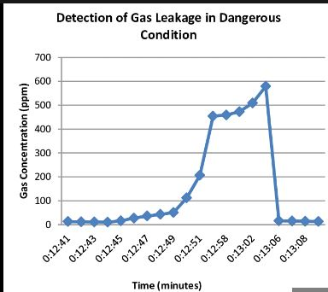

1. **ADVANTAGE AND DISADVANTAGE:**

Advantages:

* + - Because of the very narrow 0.3 nm line width of the laser emission, there is no interference from other gases.
    - Response times are in the order 1 second. This allow for fine resolution/control when making process measurements.
    - The intense laser light concentrated at the absorption wavelength enables path lengths up to 1 km to be measured.
    - An average measurement is taken over the total path so that a narrow plume of gas has less chance of escaping detection.
    - Because of the internal reference cell, the system is self calibrating.
    - There is no ‘poisoning’ or degradation of the instrument with long term exposure to a gas.
    - Can easily be conformed to be ‘Intrinsically Safe’.
    - Low maintenance and low operating costs.
    - Reliable technology.

Disadvantages:

* + - Only one gas can be measured with each instrument.
    - When heavy dust, steam or fog blocks the laser beam, the system will not be able to take measurements. This is also the case when a person or vehicle blocks the path.

**11.CONCLUSION**

In this paper we use IOT technology for enhancing the existing safety standards. While

making this prototype has been to bring a revolution in the field of safety against the leakage of

harmful and toxic gases in environment and hence nullify any major or minor hazard being caused

due to them. We have used the IOT technology to make a Gas Leakage Detector for society which

having Smart Alerting techniques involving sending text message to the concerned authority and an

ability performing data analytics on sensor. This system will be able to detect the gas in environment

using the gas sensors. This will prevent form the major harmful proble.

**12.FUTURE SCOPE:**

The future scope will be of automated bots that can be used to take necessary actions when there is a harmful detection . The bot react with the system and take immediate precaautious actions.

**13.APPENDIS**:

**SOURCE CODE:**

**#include <WiFi.h>//library for wifi**

**#include <PubSubClient.h>//library for MQtt**

**#include "DHT.h"// Library for dht11**

**#define DHTPIN 15 // what pin we're connected to**

**#define DHTTYPE DHT22 // define type of sensor DHT 11**

**#define LED 2**

**DHT dht (DHTPIN, DHTTYPE);// creating the instance by passing pin and typr of dht connected**

**void callback(char* subscribetopic, byte* payload, unsigned int payloadLength);**

**//-------credentials of IBM Accounts------**

**#define ORG "rwazv5"//IBM ORGANITION ID**

**#define DEVICE_TYPE "abcd"//Device type mentioned in ibm watson IOT Platform**

**#define DEVICE_ID "12345"//Device ID mentioned in ibm watson IOT Platform**

**#define TOKEN "12345678" //Token**

**String data3;**

**float h, t;**

**//-------- Customise the above values --------**

**char server[] = ORG ".messaging.internetofthings.ibmcloud.com";// Server Name**

**char publishTopic[] = "iot-2/evt/Data/fmt/json";// topic name and type of event perform and format in which data to be send**

**char subscribetopic[] = "iot-2/cmd/command/fmt/String";// cmd REPRESENT command type AND COMMAND IS TEST OF FORMAT STRING**

**char authMethod[] = "use-token-auth";// authentication method**

**char token[] = TOKEN;**

**char clientId[] = "d:" ORG ":" DEVICE_TYPE ":" DEVICE_ID;//client id**

**//-----------------------------------------**

**WiFiClient wifiClient; // creating the instance for wificlient**

**PubSubClient client(server, 1883, callback ,wifiClient); //calling the predefined client id by passing parameter like server id,portand wificredential**

**void setup()// configureing the ESP32**

**{**

**Serial.begin(115200);**

**dht.begin();**

**pinMode(LED,OUTPUT);**

**delay(10);**

**Serial.println();**

**wificonnect();**

**mqttconnect();**

**}**

**void loop()// Recursive Function**

**{**

**h = dht.readHumidity();**

**t = dht.readTemperature();**

**Serial.print("temp:");**

**Serial.println(t);**

**Serial.print("Humid:");**

**Serial.println(h);**

**PublishData(t, h);**

**delay(1000);**

**if (!client.loop()) {**

**mqttconnect();**

**}**

**}**

**/.....................................retrieving to Cloud.............................../**

**void PublishData(float temp, float humid) {**

**mqttconnect();//function call for connecting to ibm**

**/\***

**creating the String in in form JSon to update the data to ibm cloud**

**\*/**

**String payload = "{\"temp\":";**

**payload += temp;**

**payload += "," "\"Humid\":";**

**payload += humid;**

**payload += "}";**

**Serial.print("Sending payload: ");**

**Serial.println(payload);**

**if (client.publish(publishTopic, (char*) payload.c_str())) {**

**Serial.println("Publish ok");// if it sucessfully upload data on the cloud then it will print publish ok in Serial monitor or else it will print publish failed**

**} else {**

**Serial.println("Publish failed");**

**}**

**}**

**void mqttconnect() {**

**if (!client.connected()) {**

**Serial.print("Reconnecting client to ");**

**Serial.println(server);**

**while (!!!client.connect(clientId, authMethod, token)) {**

**Serial.print(".");**

**delay(500);**

**}**

**initManagedDevice();**

**Serial.println();**

**}**

**}**

**void wificonnect() //function defination for wificonnect**

**{**

**Serial.println();**

**Serial.print("Connecting to ");**

**WiFi.begin("Wokwi-GUEST", "", 6);//passing the wifi credentials to establish the connection**

**while (WiFi.status() != WL_CONNECTED) {**

**delay(500);**

**Serial.print(".");**

**}**

**Serial.println("");**

**Serial.println("WiFi connected");**

**Serial.println("IP address: ");**

**Serial.println(WiFi.localIP());**

**}**

**void initManagedDevice() {**

**if (client.subscribe(subscribetopic)) {**

**Serial.println((subscribetopic));**

**Serial.println("subscribe to cmd OK");**

**} else {**

**Serial.println("subscribe to cmd FAILED");**

**}**

**}**

**void callback(char* subscribetopic, byte* payload, unsigned int payloadLength)**

**{**

**Serial.print("callback invoked for topic: ");**

**Serial.println(subscribetopic);**

**for (int i = 0; i < payloadLength; i++) {**

**//Serial.print((char)payload[i]);**

**data3 += (char)payload[i];**

**}**

**Serial.println("data: "+ data3);**

**if(data3=="lighton")**

**{**

**Serial.println(data3);**

**digitalWrite(LED,HIGH);**

**}**

**else**

**{**

**Serial.println(data3);**

**digitalWrite(LED,LOW);**

**}**

**data3="";**

**}**

**DEMO LINK:**

[**https://github.com/IBM-EPBL/IBM-Project-39572-1660460843**](https://github.com/IBM-EPBL/IBM-Project-39572-1660460843)

[**https://wokwi.com/projects/348689083276460627**](https://wokwi.com/projects/348689083276460627)

[**https://wokwi.com/projects/322410731508073042**](https://wokwi.com/projects/322410731508073042)

.